Cartoon and Image Analysis

Methods of Cartoon and Image Analysis

In Social Studies you will be expected to interpret political cartoons and images. These will be put in assignments and on exams, which will then require you to think about what they "are trying to say".
Why do teachers do this?
Let's face it…it's not that hard to memorize a few facts about a school subject. Basic recall (remembering things someone told you) is not a very advanced way of thinking. To get to higher levels of thinking, you have to take a piece of information and evaluate it. An excellent way to do that is to analyze and interpret an editorial cartoon or image.

How to Analyze Images
Open this How to Read a Picture lesson for guidelines to help you analyze images, posters and photographs.
Open this Guide to analyzing different kinds of sources.

Other Tools and Methods for Analyzing and Interpreting Sources
Use one of the resources or tools below to help you with image and cartoon analysis. Choose the platforms and methods that best suit your learning style:

PowerPoint
Download this slideshow: How to Interpret the Basic Elements of Political Cartoons

Analysis Chart
Use this Political Cartoon Analysis table to help you interpret cartoons.

Questions to Ask
This Cartoon Analysis questions.doc outlines the skills and questions to ask about political cartoons.

How-to Wiki
Click on this link to the Wiki and consider the different methods for analyzing a political cartoon.

Video on Analyzing Images
View this short video, Explain the Image:
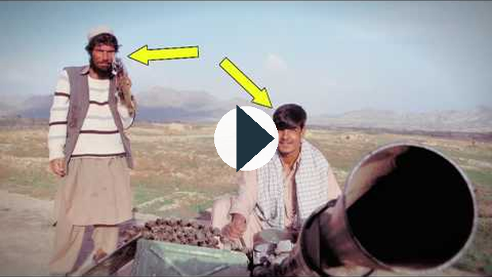
https://www.youtube.com/watch?v=lz_Tqu1UUpI
Or click this link to see the video in a new window.

Other resources:

SWAP Method
Symbols: Describe the symbols you see drawn
Words: What do the words tell you?
Action: What action is taking place?
Point: What point is the cartoonist making?
Paragraph: Write a paragraph which analyzes the cartoon based on the SWAP observations above.
Understand:
1. Go to the handout SWAP and first, take a look at the cartoon.
2. Step by step go through the questions on the handout.
Practice:
Choose one of the following two cartoons, Homeschooling OR Vancouver Police, and work through the SWAP process.
Find a political cartoon about ideologies:
- Use this website link to find a cartoon of your choice.
- Try one of these cartoons.
- Complete the Political Cartoon handout.

Make your own cartoon
- Create your own political cartoon. You must portray an opinion about a current event or political issue.

Saving cartoons from the website mentioned above
When you find the cartoon you want to use, make sure you left click the thumbnail of the cartoon. This will open a bigger version. Then right-click this bigger image and select Save Image As from the list that appears on your screen after right clicking. This will give you the good quality image rather than the tiny poor quality thumbnail image.
©2020 CBe-learn - Calgary Board of Education

